2.1 Atomic structure
Name: ____________________ Class: ____________________ Due date:
1. - (0620- W 2012- Paper 1 (Core)/1- Q4) - ATOMS AND ELEMENTS
Which statements comparing the properties of electrons, neutrons and protons are correct? （ ）
 | neutrons and protons are both heavier than electrons | only electrons and neutrons are charged
A | ✓ | ✓
B | ✓ | ×
C | × | ✓
D | × | ×

2. - (0620- W 2014- Paper 1 (Core)/3- Q4) - ATOMS AND ELEMENTS
Which statement about a neutron is not correct? （ ）
A It can be present in different numbers in atoms of the same element.
B It has no electrical charge.
C It is always found in the nucleus of an atom.
D It weighs much less than a proton.

3. - (0620- W 2015- Paper 1 (Core)/1- Q3) - ATOMS AND ELEMENTS
Which statement about atoms is correct? （ ）
A Atoms contain protons and electrons in the nucleus.
B Neutrons are negatively charged.
C Protons are positively charged.
D The nucleon number is the number of neutrons.

4. Which statements comparing the properties of electrons, neutrons and protons are correct? （ ）
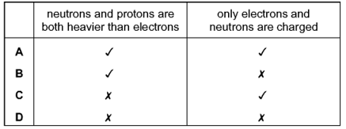
5. - (0620- S 2019- Paper 4 (Extended)/3- Q1) - ATOMs AND ELEMENTS
Atoms contain particles called electrons, neutrons and protons.
a.Complete the table.
particle | where the particle is found in an atom | relative mass | relative charge
 | orbiting the nucleus | 1/1840
 | in the nucleus |  | +1

